# **Customer Shopping Trends. Dataset and Report**

**About the dataset:** This dataset encompasses a variety of factors related to customer shopping preferences, providing essential information for businesses aiming to improve their understanding of their customer base. The dataset includes details such as **customer age, gender, purchase amounts, preferred payment methods, purchase frequency, and feedback ratings**. Additionally, it contains data on the types of items purchased, shopping frequency, preferred seasons for shopping, and interactions with promotional offers. With a dataset size of 3900 records, it serves as a foundational resource for businesses looking to leverage data-driven insights to enhance decision-making and formulate customer-centric strategies.   
  
The dataset is found via Kaggle. All the necessary information about dataset columns and filled data can be found following this [link](https://www.kaggle.com/datasets/iamsouravbanerjee/customer-shopping-trends-dataset):

**Performed Actions:** I have performed analytics on the provided dataset, extracting valuable insights and trends. The findings have been compiled into a comprehensive report, offering actionable information for informed decision-making and the development of customer-centric strategies.  
  
First of all I did the dataset analysis using Power Query:

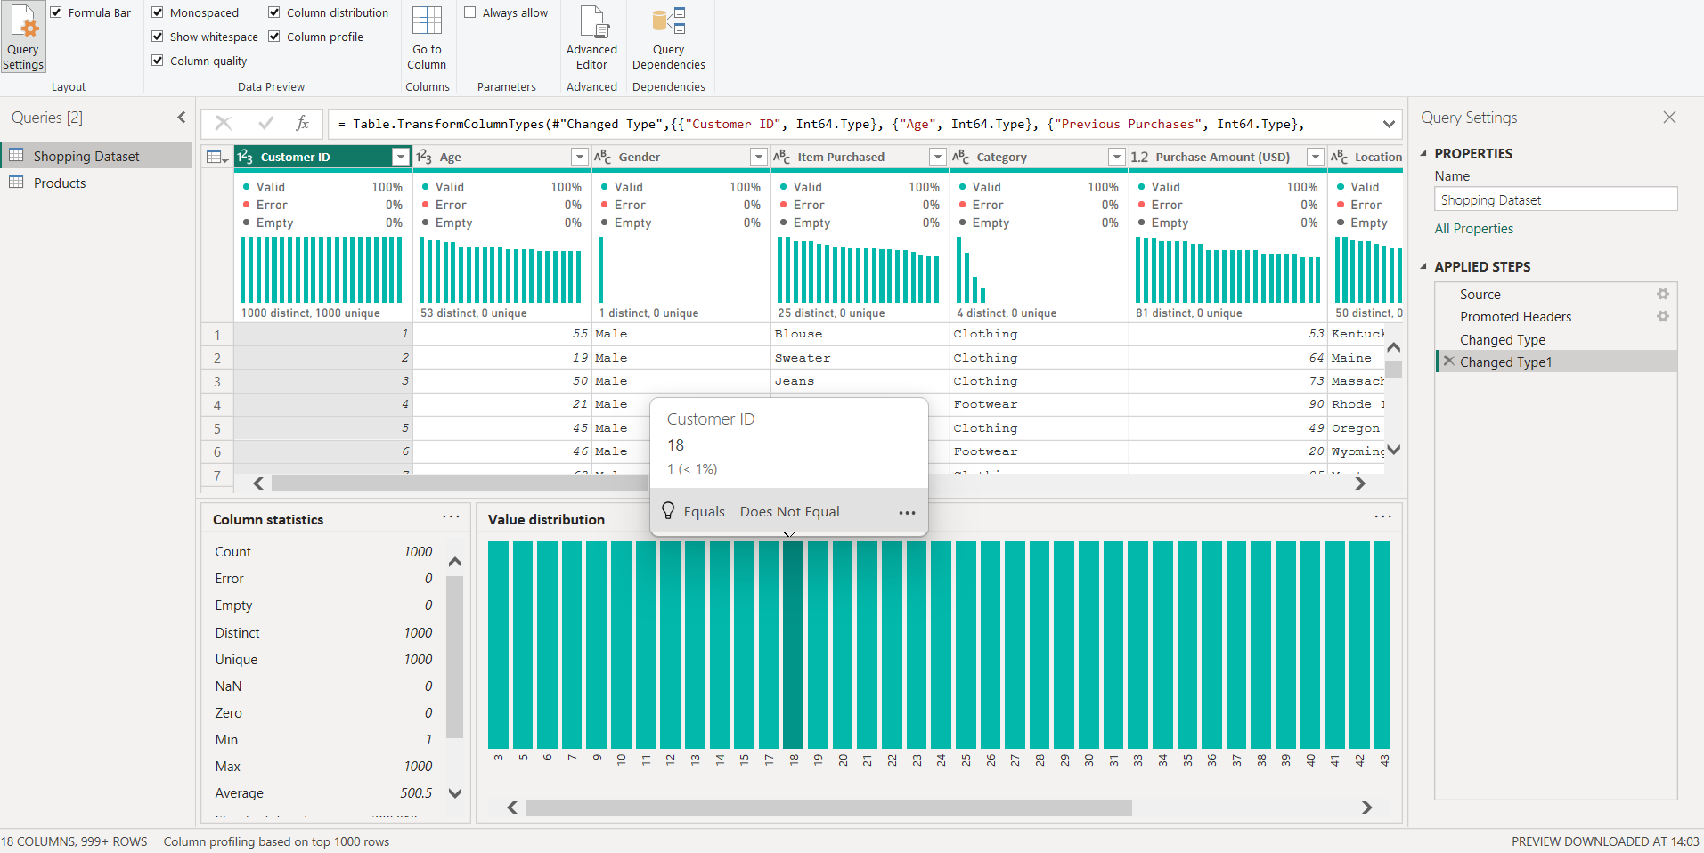  
The necessary changes are made after exploring the dataset: promoting first rows, defining the data types etc.

Then It is important to understand the stored data and what it is about. The information might be double stored because of columns representing the same data in different forms.   
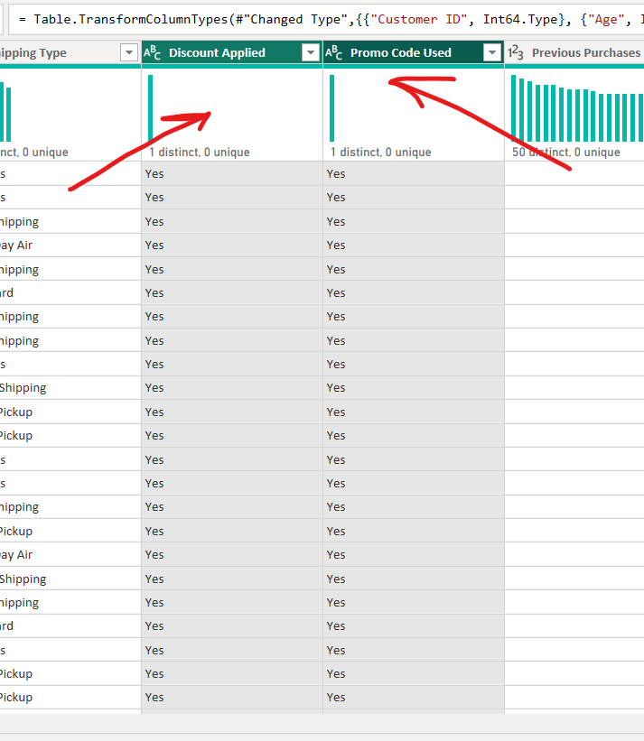  
In this screen we see the same information represented in two columns. If the Item is discounted then the promo code is used, and if the promocode is used then it is discounted (Checked up the relation, won’t have the same logic with different datasets). So, to avoid a refreshing workload, we can remove one of the columns, in my case, I have removed the “Promo Code Used” column.  
Next thing that I did, is to pivot the and get average totals for each product category and item couple. I pivoted the “rating”, “Purchase Amount (USD)” columns and counted Distinct rows for each duo.  
  
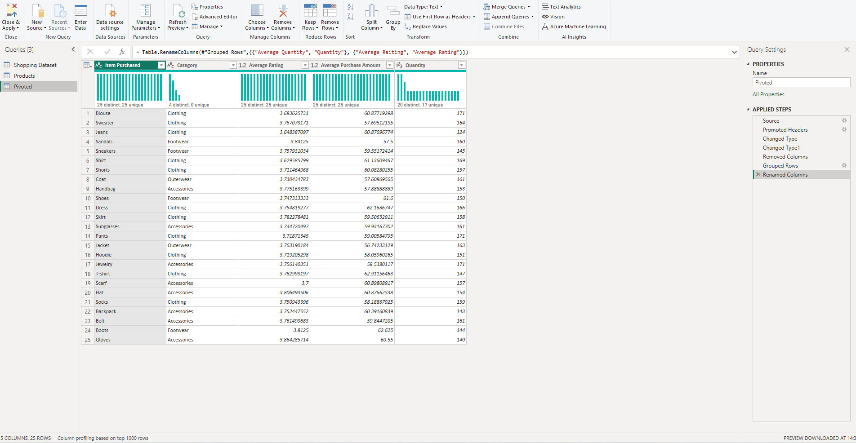  
  
This step is very relevant, because we could do the same after close and apply, by creating a new table and counting the demanding totals.  
Close and Apply.  
  
Next Thing I did was create a Products column with “Total Sales”, “Quantity of Discounted Sold Items” and “Quantity of Not Discounted Items” columns.  
  
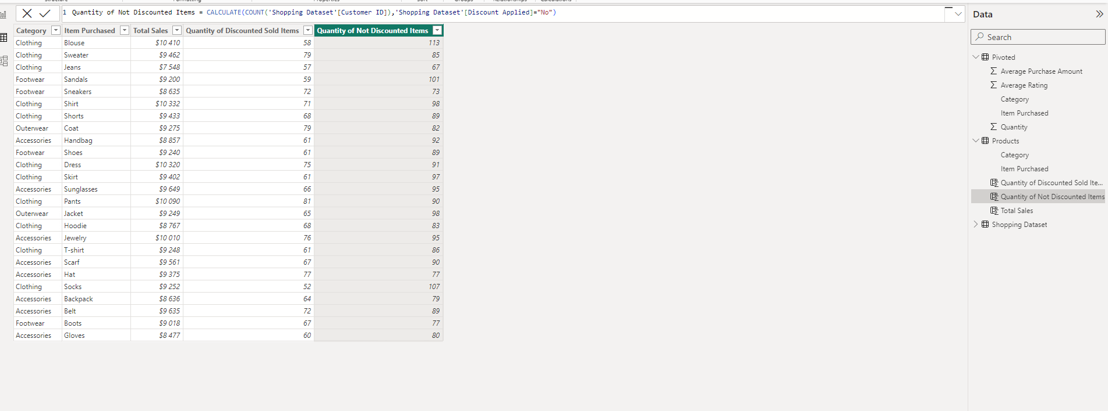  
  
Although this dataset is simple and does not contain complex calculations, we tried to fetch the insights.  
For insights and clarification of goals, we need to formulate questions through which we will find patterns, trends and solve business issues.

That is why we need to formulate business questions and represent the answers in our report:  
**1. Demographic Analysis:**

- What is the age distribution of our customer base, and how does it correlate with purchase behavior?

- Is there any gender-specific patterns in terms of preferred payment methods or shopping frequency?

**2. Purchase Behavior:**

- What is the average purchase amount, and how does it vary across different customer segments?

- Can we identify any trends or patterns in the types of items purchased by different age groups or genders?

- How does customer feedback and ratings correlate with the amount spent or the frequency of purchases?

**3.** **Payment Preferences:**

- Which payment methods are most used by our customers, and does this vary based on demographics?

- Are there any correlations between payment preferences and customer satisfaction?

**4. Shopping Patterns:**

- What are the peak shopping seasons, and how do they influence customer behavior?

- Is there a relationship between shopping frequency and interactions with promotional offers?

**5. Customer Satisfaction and Loyalty:**

- How do customer feedback ratings correlate with overall satisfaction and repeat business?

- Can we identify factors that contribute to customer loyalty, and how can we enhance these factors?

**6. Promotional Strategies:**

- What types of promotional offers are most effective in driving customer engagement and sales?

- How do different customer segments respond to specific promotions?

**Results**

After loading the dataset into Power BI, and creating the necessary tables and modifications, we should also create some measures, and measurements to bring up values and calculations for further analysis. In the provided screenshot in the data field, we can see the calculations that I did. Also here is the result.  
  
  
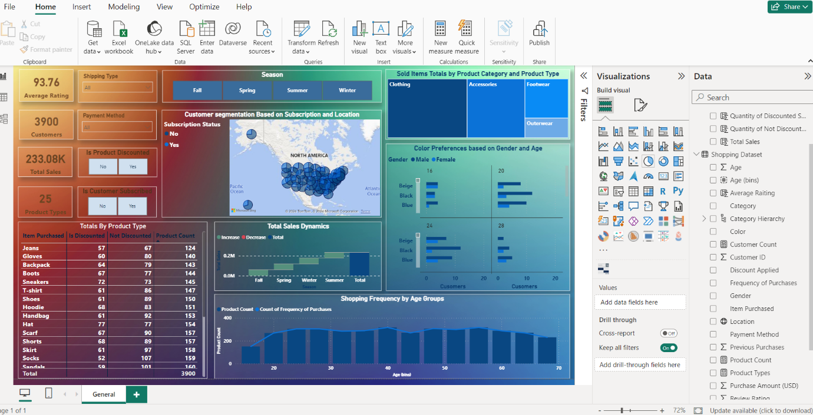  
  
Here are used different visualizations: slicers for filtering (dropdowns and buttons), bar charts, card visuals, map visualizations and so on.